Web Integrity

Integration with the resources such as Internet would be very crucial for this process as it not only ease the user to enroll, record and grab the information of him/herself but also enables the employees behind the project to manage and handle the data that is gets available to them online and as well as offline. With the help of languages like PHP, HTML and databases like MYSQL the ease of handling the data becomes more efficient. There are sub processes comprehends with Internet Intergrity which are as follows:

Office Automated System

There are multiple online document management apps like Google Sheets and Google documents which automates the task that collects, process, store and transmit data and other form of communication among individual, group and organization. Example includes word processing, electronic mail, desktop publishing and image processing.

Expert Information System

It is programmed through various languages such as Python, Django etc. which reads human behavior by which they create more data which gets stored in the databases and creates a newer type of information with the help of Artificial Intelligence and creates unique options for the users to get more benefit.

Signup/Login

Before using any kind of services that are provided and will be provided the user needs to signup and the employees which are working for the welfare needs to login which is only available through internet integration with the software.

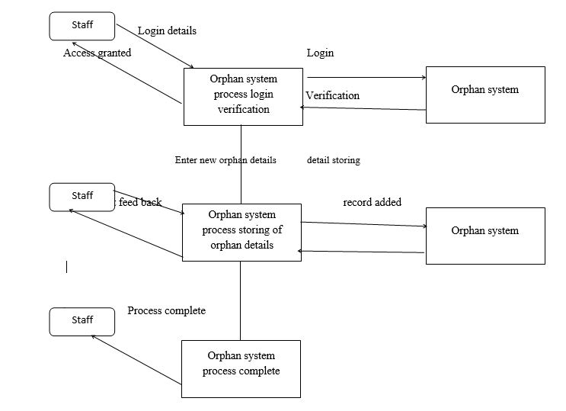

Fundraising

Without any kind of fundraising or donor the project for the welfare of the society can’t be spread to people who are in need and also to the people those who wants to donate. Fundraising can be achieved by the people those who seek for the welfare of the society. With the help of government services and gathering voluntary financial contributions by allowing individuals, groups, businesses, charitable foundations etc. There are multiple sub processes which can be implemented to achieve a better scope of fundraising.

Individual Donor

Donors can be parents, friends, private foundations, small corporations etc. which can provide small contributions In order to help other services to become more easily and effortlessly available to the users and fundraising by the individuals can become more efficient as it builds trust with the independent body.

Group Donors

Non-Profitable agencies, Government Services or Corporate societies can also become a part of the platform with which the ease of platform to donate the donor will also receive reward and recognition when the initiate for a greater cause.

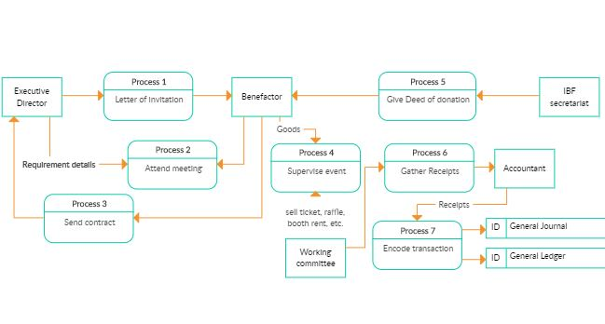

Analytics

Analytics can be used by project managers to assess a project’s viability, gauge which projects are meeting Key Performance Indicators (KPI) and provide progress updates to stakeholders. Gathering and recording data for all projects is important, so a manager has the ability to see how a change made in Project A impacts Projects B, C and D. Through these insights, project managers can instantly determine whether a project or task should proceed as planned, change course or be discarded altogether.

Data can tell a project manager if a software launch is on schedule or not. Analytics can tell a project manager how each day of delay in delivering the product to consumers will impact the company’s profits. Business analysts (BAs) use advanced data modeling and data warehousing to show actual costs across possible dates of completion, based on current and alternative rates of productivity. They can also predict customer responses to various product offerings, pricing and delivery methods.

Analytics can forecast resource shortages, equipment failures, asset availability, production and maintenance costs, and any number of other competitive factors a business may face. Using analytics, project managers have the power to see how a potential task affects outcomes before they happen – and to make sound, strategic decisions based on that information.

Beyond simply gathering data from one project, analytics allow project managers to heighten their understanding of how every current or proposed project fits into the overall picture and affect each other. Whether the goal of a project is to increase quality, resolve a system problem, improve operations or prevent losses, analytics can give project managers the insight necessary to make it more successful.